The Passive Club (TPC)
Meeting Minutes for December 21, 2022
Meeting called to order at 11:02 AM | Meeting adjourned at 11:50 AM

Officers | Name | Officers | Name
President | Manu Pasari | Vice-President | Helen Sorser
Treasurer | Georgeline Mitchell | Treasurer (bkp)
Secretary | Sriram Padi | Secretary (bkp)

Member Name | Present | Member Name | Present | Member Name | Present
Alan Hull | ☒ | Helen Sorser | ☒ | Sriram Padi | ☐
Carolyn Collins | ☐ | Manu Pasari | ☐ | Javarri Little | ☐
Catherine Chall | ☐ | Morresa Meyer | ☐ | Youmin Zheng | ☐
Damian Stone | ☐ | Percy Antonio | ☐ | Jeff Scott | ☐
Jody Tarquinto | ☒ | Phil York | ☒ |  | ☐
John Janci | ☐ | Scot Ferman | ☐ |  | ☐
Georgeline Mitchell | ☒ | Srinivas Ponugoti | ☒ |  | ☐
Gerry Wholihan | ☐ |  |  |  | ☐

- Georgeline reviewed meeting minutes from 11/16/2022:
Al motioned to accept
Jody second, no one opposed
Motion passed.

- Current Months Treasurer’s Report was reviewed by Georgeline with assistance from Helen:
Available Cash for investment $1,968.39 only what is in Vanguard due to time constraints and Phil and Issac’s withdrawals. Amendment for Phil and Issac’s withdrawal with amended valuation date of 11/15/2022 are the following: Issac $12,126.84 and Phil $9,682.60 for total of $21,809.44.
Jody motioned to accept
Helen second, no one opposed
Motion passed.

- Portfolio Action – Buys/Sells:

Documents location:
https://docs.google.com/spreadsheets/d/1j4jKxPI5rqnW1hsBRrX63jzIZZ0Dl80ak9CXDc2lJDU/edit?usp=sharing

December Buys:
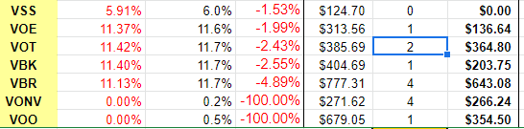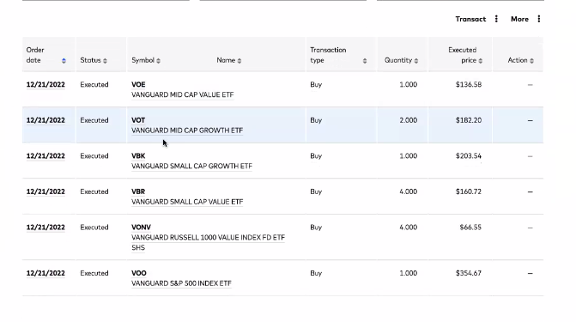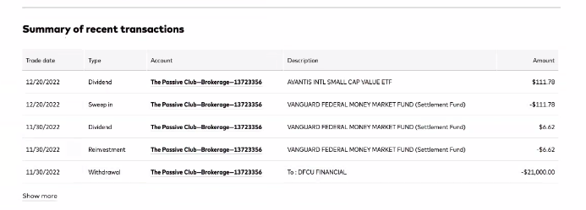

- Old Business
  - Audit update presented by Jody:
    - Vote on Scott and Jody’s recommendation:
      - Members should add phone numbers to contact information in the Bivio rooster
        - As of 7/15/22 – We still need 17 people’s phone numbers
      - Receipts should be uploaded to Bivio as PDF in receipt folder.
      - Pdf statements (DFCU & Vanguard) should be uploaded to Bivio.
      - Minutes and Treasures Report to contain more details on expenses and withdrawals.
      - Recommend we target deposits after 1st of the month and before meeting (especially at end of year – Dec).
      - Recommend Before leaving the club and receiving final check – to confirm deposits and withdrawal amounts! Recommend a Quarterly and or Simi Annual Audits.
  - Jody and Manu will meet with Helen to simplify the Treasurer Report.
  - Discuss revisiting of how Bivio site is set up per Helen – “The Bivio site where we store our club documents like meeting minutes, financial statements and information, guidelines and supporting documents needs to be revisited. It is hard to navigate, and we have documents in multiple places, like partnership agreements, club audit documents, etc. We need to create a road map of the site, evaluate available documents, purge what is not needed and align what's needed. For example, the partnership agreement needs to be signed every year.”
    - Site cleaning
    - Creating a partnership agreement
  - Vanguard access – discussion with John
  - Vanguard allows to buy partial shares (per Jody) and it is a subject for discussion
    - Validate if Bivio allows partial shares
    - Complexity of execution (for the treasurer)
  - Vanguard $7 discrepancy – Helen to prepare analysis. Meet with Jody and Manu
  - TPC Bivio Renewal of $349 for 2022 (was previously $179).
    - The allocation to the members will be higher.
    - Do we want to keep with Bivio due to higher costs? We have been with Bivio since 2008. John will ask Bob for potential options.
  - TPC Target Percentages reset effective October:
    - John and Jody will put together something and will send email letting us know how we have done so far, and next month we will vote month on the potential reset.
  - Vote on TPC Target Percentage reset proposal set by Jody via TPC email
    - Is below:
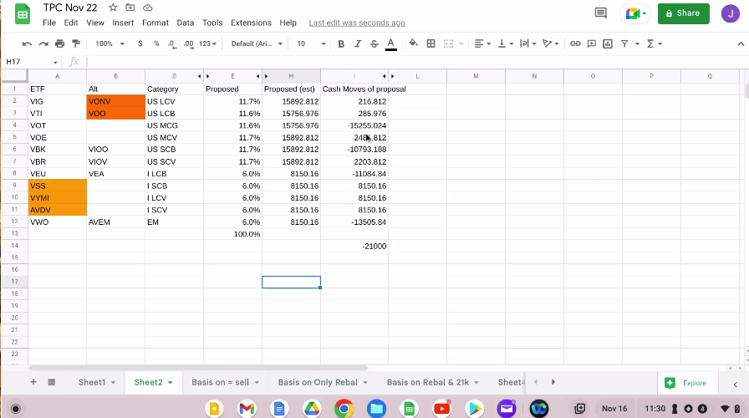
    - Propose new money will go to new funds VONV and VOO. Add VSS, VYMI and AVDV being added. There will be no fees associated because it is not a Vanguard fund.
Selling to fund the new positions and for Phil and Issac York. We will need to wait until the 11/23/22 to sell but will have in taxes from selling for Phil and Issac.
Jody will send an email to the whole club asking members to respond if there are any objectives.
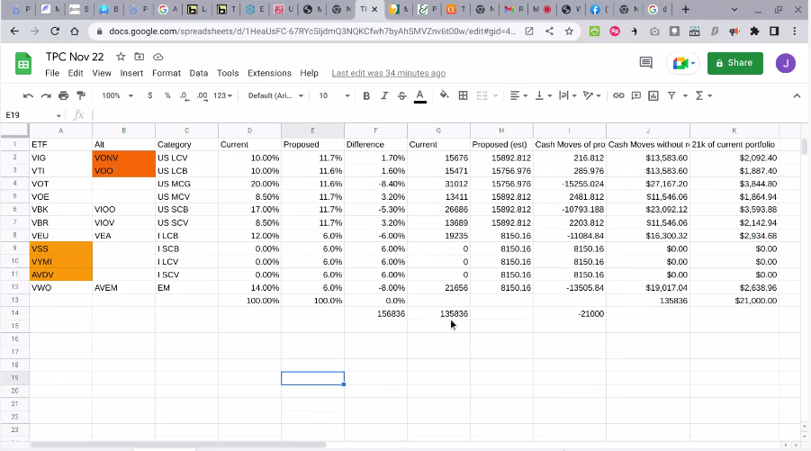

Manu motioned to accept as it presented but dependent on no strong objectives raised via email.
John second, no one opposed
Motion passed.
Additional session to figure out the execution will be sent by Jody, Helen and Georgeline.

Below is screenshot of the email sent by Jody on 11/16/22 after the meeting to all members.
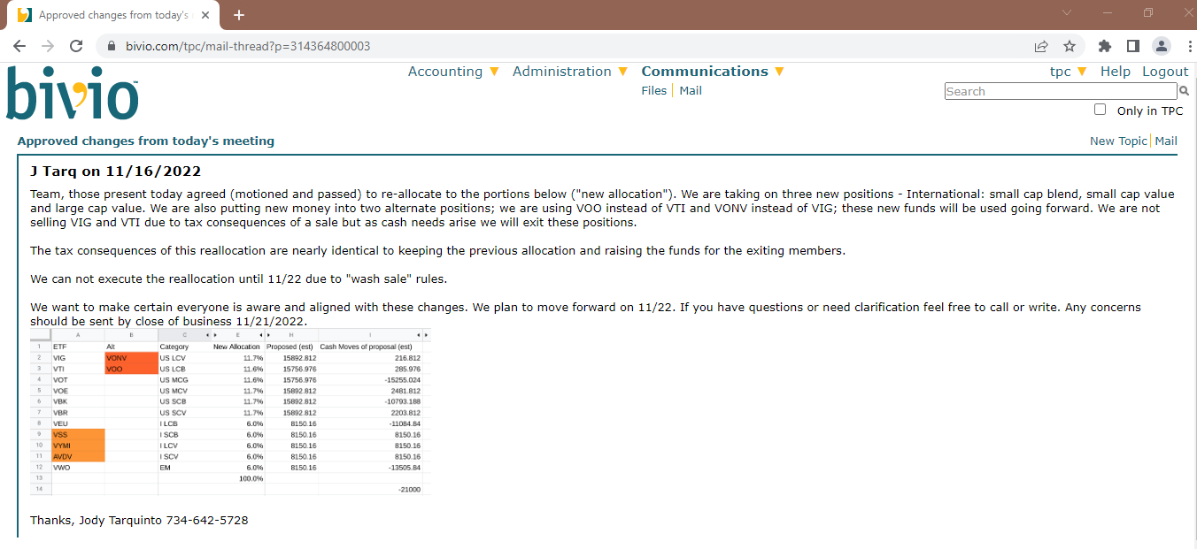

- New Business
- IRS does not acknowledge that they received our club’s request for tax extension on time. John and Helen worked together to file a dispute against the club tax bill sent to John. Please see email from Manu for additional information. There might be an approximate charge of $1260+ per club member for 2021 members if we do not get it turn over. We might have to contact Phil & Isaac for the payment if we are not successful.
- We need 2 more auditors – Jody has volunteered.
Submitted Georgeline Mitchell

