The Passive Club (TPC)
Meeting Minutes for February 16, 2022
Meeting called to order at 11:03AM | Meeting adjourned at 11:29 AM

Officers | Name | Officers | Name
President | Phil York | Vice-President | Manu Pasari
Treasurer | Helen Sorser | Treasurer (bkp)
Secretary | Georgeline Mitchell | Secretary (bkp)

Member Name | Present | Member Name | Present | Member Name | Present
Alan Hull | ☒ | Helen Sorser | ☒ | Sriram Padi | ☐
Carolyn Collins | ☒ | Manu Pasari | ☒ | Javarri Little | ☐
Catherine Chall | ☐ | Morresa Meyer | ☐ | Youmin Zheng | ☐
Damian Stone | ☐ | Percy Antonio | ☐ | Jeff Scott | ☐
Jody Tarquinto | ☒ | Phil York | ☒ |  | ☐
John Janci | ☒ | Scot Ferman | ☐ |  | ☐
Georgeline Mitchell | ☒ | Sherry Steinhauer | ☐ |  | ☐
Gerry Wholihan | ☐ | Srinivas Ponugoti | ☒ |  | ☐

- Georgeline reviewed meeting minutes from 1/19/2022:
Al motioned to accept
Helen second, no one opposed
Motion passed.

- Current Months Treasurer’s Report was reviewed by Helen:
Available Cash for investment $1,596.94
Jody motioned to accept
Manu second, no one opposed
Motion passed.

- Portfolio Action – Buys/Sells:

Documents location:
https://docs.google.com/spreadsheets/d/1j4jKxPI5rqnW1hsBRrX63jzIZZ0Dl80ak9CXDc2lJDU/edit?usp=sharing

February Sells:

Suggested Buys:

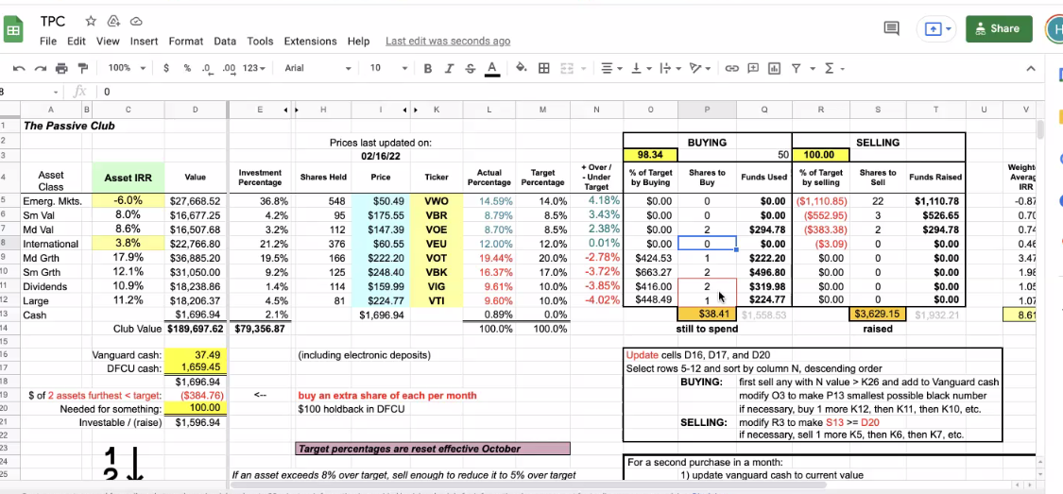

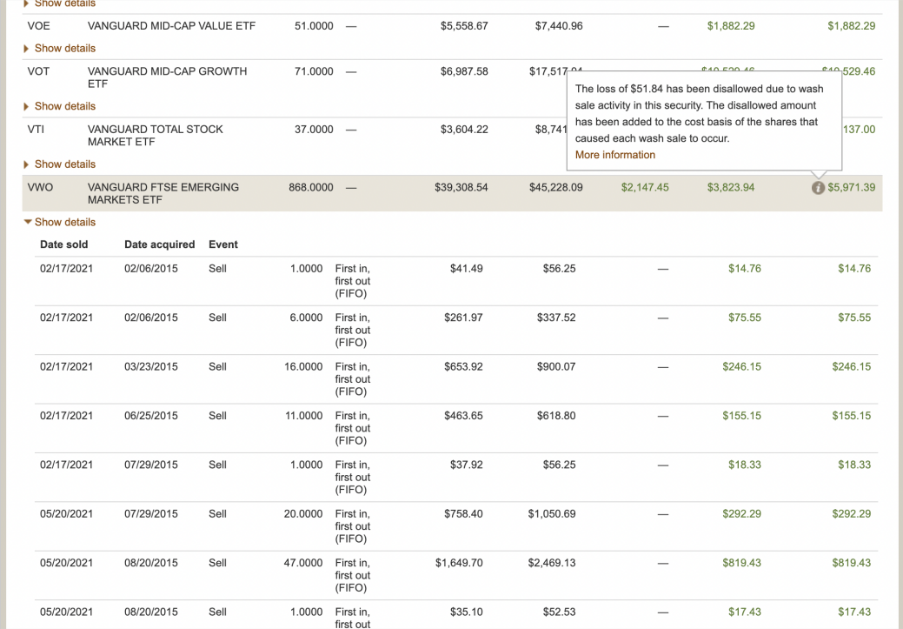

- Old Business
  - Audit – submit request for volunteers (Marina and Raymond if there are no volunteers)
Define the process of authentication between DFCU and Vanguard or other options to transfer funds immediately for 2021.
- Jody Tarquinto has volunteered to do Audit
- Question – do we have the 2 who will be doing the audit finalize? Jody and Cathy if Jerry cannot find someone else.
  - Actually auditors are 2021 Jody and Scot Freman

  - Why is the meeting so short – request extending it 15 minutes or 30 minutes? Maybe move it to another day – Brought up by Jody Subject to discussion next month
    - Recommend that read and dialogue (Simple Path to Wealth and Common-Sense Investing) – Brought up by Jody

- New Business
- Presented by Helen – Vanguard Brokerage Report “Details for Dividends and Distributions” -- issues is the “Short Term Transactions for Covered Tax Lots”. It is a Wash Sale Loss (higher capital gain taxes). For VWO EFT. The Bivio entry needs to correct the entry to “Wash Sale Loss” before we can produce a 10-99. Helen contacted Bivio 2/15/22 and gave them their requested forms.
- Audit update presented by Jody:
  - Helen needs help to correct issues identified.
  - There is a disconnect – Long Term and Short-Term gains are off about $70. Both Bivio and Vanguard does not match.
  - The 1099 Tax form has to be provided no later than March 15, 2022
  - There will be an offline meeting to resolve both #1 and #2. Who is involved Philip, Al, Manu, John Janci, Scott and Jody to discuss. Manu will set up the meeting.
- Helen may be out earlier due to the family circumstances and Manu has volunteer to cover her, if necessary.

Submitted Georgeline Mitchell

