The Passive Club (TPC)
Meeting Minutes for March 16, 2022
Meeting called to order at 11:01AM | Meeting adjourned at 11:34 AM

Officers | Name | Officers | Name
President | Phil York | Vice-President | Manu Pasari
Treasurer | Helen Sorser | Treasurer (bkp)
Secretary | Georgeline Mitchell | Secretary (bkp)

Member Name | Present | Member Name | Present | Member Name | Present
Alan Hull | ☒ | Helen Sorser | ☒ | Sriram Padi | ☐
Carolyn Collins | ☐ | Manu Pasari | ☒ | Javarri Little | ☐
Catherine Chall | ☒ | Morresa Meyer | ☐ | Youmin Zheng | ☐
Damian Stone | ☐ | Percy Antonio | ☒ | Jeff Scott | ☐
Jody Tarquinto | ☒ | Phil York | ☒ |  | ☐
John Janci | ☐ | Scot Ferman | ☒ |  | ☐
Georgeline Mitchell | ☒ | Sherry Steinhauer | ☐ |  | ☐
Gerry Wholihan | ☐ | Srinivas Ponugoti | ☐ |  | ☐

- Georgeline reviewed meeting minutes from 2/16/2022:
Al motioned to accept
Jody second, no one opposed
Motion passed.

- Current Months Treasurer’s Report was reviewed by Helen:
Available Cash for investment $1,644.86 (included left over $300 from DFCU)
Catherine motioned to accept (condition that Helen will validate Catherine’s deposit)
Jody second, no one opposed
Motion passed.

- Portfolio Action – Buys/Sells:

Documents location:
https://docs.google.com/spreadsheets/d/1j4jKxPI5rqnW1hsBRrX63jzIZZ0Dl80ak9CXDc2lJDU/edit?usp=sharing

March Sells:

Suggested Buys:

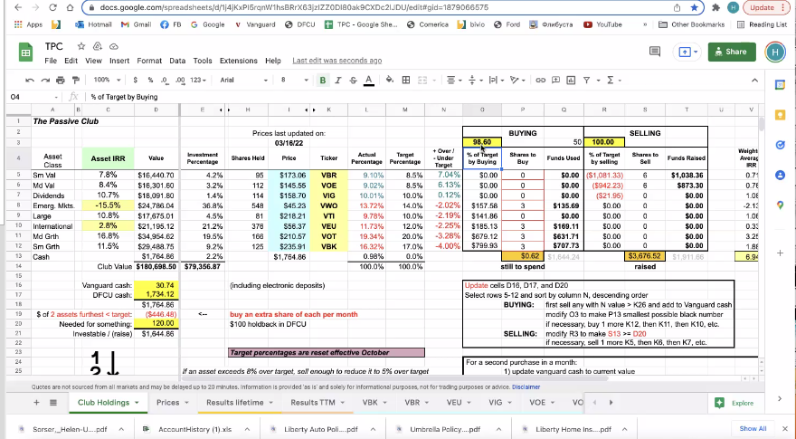

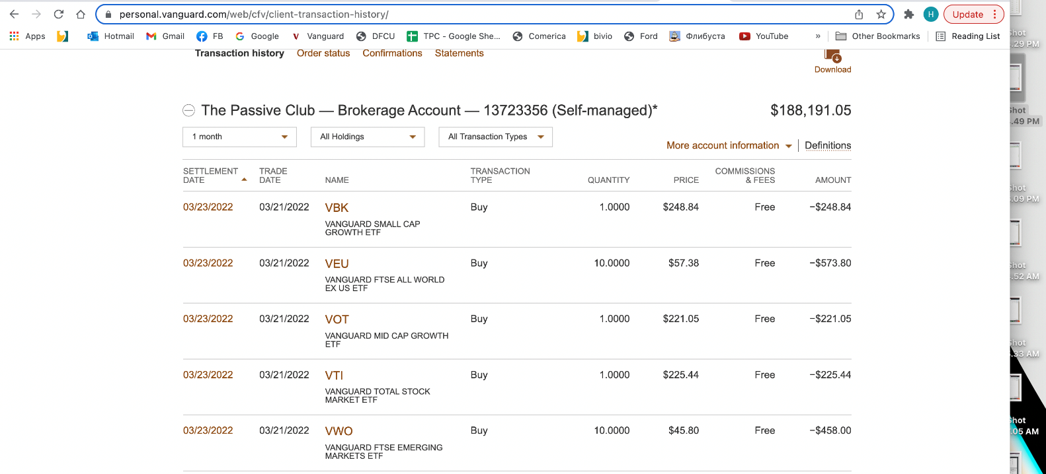

- Old Business
  - Audit – submit request for volunteers (Marina and Raymond if there are no volunteers)
Define the process of authentication between DFCU and Vanguard or other options to transfer funds immediately for 2021.
- Jody Tarquinto has volunteered to do Audit
- Question – do we have the 2 who will be doing the audit finalize? Jody and Cathy if Jerry cannot find someone else.
  - Actually, auditors are 2021 Jody Tarquinto and Scot Freman
  - Presented by Helen – Vanguard Brokerage Report “Details for Dividends and Distributions” -- issues is the “Short Term Transactions for Covered Tax Lots”. It is a Wash Sale Loss (higher capital gain taxes). For VWO EFT. The Bivio entry needs to correct the entry to “Wash Sale Loss” before we can produce a 10-99. Helen contacted Bivio 2/15/22 and gave them their requested forms.
    - Update from Helen 3/16/2022:
      - VWO was updated for the Wash Sales and Historical Data and it was $300 not the $150. We need to collect the $300 and distributed among all the members.
      - Reminded that there are VOT and VEU has to be corrected. Bob said that Jody knows how to fix the historical and Helen will work with him to fix it.
      - Bob joined us for today’s meeting saying that we have to amend the taxes and refill amended returns for the club and each individual member might want to refile amended returns for the years fixed.
      - Helen cannot find the taxes for the prior years, it is not in Bivio -- Helen will confirm the tax years needed
      - Need separate meeting to discuss next steps
  - Audit update presented by Jody:
    - Helen needs help to correct issues identified.
    - There is a disconnect – Long Term and Short-Term gains are off about $70. Both Bivio and Vanguard does not match.
    - The 1099 Tax form has to be provided no later than March 15, 2022
    - There will be an offline meeting to resolve both #1 and #2. Who is involved Philip, Al, Manu, John Janci, Scott and Jody to discuss. Manu will set up the meeting.
    - Sriram Padi – Needs to complete the audit form in Bivio (Confirming all deposits and withdrawals are correct)
    - Vote to accept the audit:
      - All deposits and withdrawals are correct but Sriram Padi did not confirm
Jody motioned to accept
Percy no one opposed
Motion passed
    - Vote on Scot and Jody’s recommendation:
      - Members should add phone numbers to contact information
      - Receipts should be uploaded to Bivio as PDF in receipt folder.
      - Pdf statements (DFCU & Vanguard) should be uploaded to Bivio.
      - Minutes and Treasures Report to contain more details on expenses and withdrawals.
      - Recommend we target deposits after 1st of the month and before meeting (especially at end of year - Dec).
      - Recommend Before leaving the club and receiving final check - to confirm deposits and withdrawal amounts! Recommend a Quarterly and or Simi Annual Audits.
  - Helen may be out earlier due to the family circumstances and Manu has volunteer to cover her, if necessary.

- New Business

Submitted Georgeline Mitchell

