The Passive Club (TPC)
Meeting Minutes for July 20, 2022
Meeting called to order at 11:02 AM | Meeting adjourned at 11:32 AM

Officers | Name | Officers | Name
President | Phil York | Vice-President | Manu Pasari
Treasurer | Helen Sorser | Treasurer (bkp)
Secretary | Georgeline Mitchell | Secretary (bkp)

Member Name | Present | Member Name | Present | Member Name | Present
Alan Hull | ☒ | Helen Sorser | ☒ | Sriram Padi | ☐
Carolyn Collins | ☐ | Manu Pasari | ☒ | Javarri Little | ☐
Catherine Chall | ☐ | Morresa Meyer | ☒ | Youmin Zheng | ☐
Damian Stone | ☐ | Percy Antonio | ☐ | Jeff Scott | ☐
Jody Tarquinto | ☒ | Phil York | ☐ |  | ☐
John Janci | ☐ | Scot Ferman | ☐ |  | ☐
Georgeline Mitchell | ☒ | Srinivas Ponugoti | ☒ |  | ☐
Gerry Wholihan | ☐ |  |  |  | ☐

- Georgeline reviewed meeting minutes from 6/15/2022:
Manu motioned to accept
Jody second, no one opposed
Motion passed.

- Current Months Treasurer’s Report was reviewed by Helen:
Available Cash for investment $2,443.49
Jody motioned to accept
Morresa second, no one opposed
Motion passed.

- Portfolio Action – Buys/Sells:

Documents location:
https://docs.google.com/spreadsheets/d/1j4jKxPI5rqnW1hsBRrX63jzIZZ0Dl80ak9CXDc2lJDU/edit?usp=sharing

July Buys:

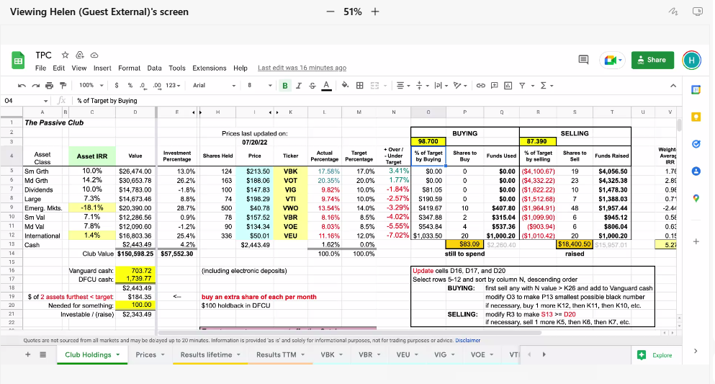

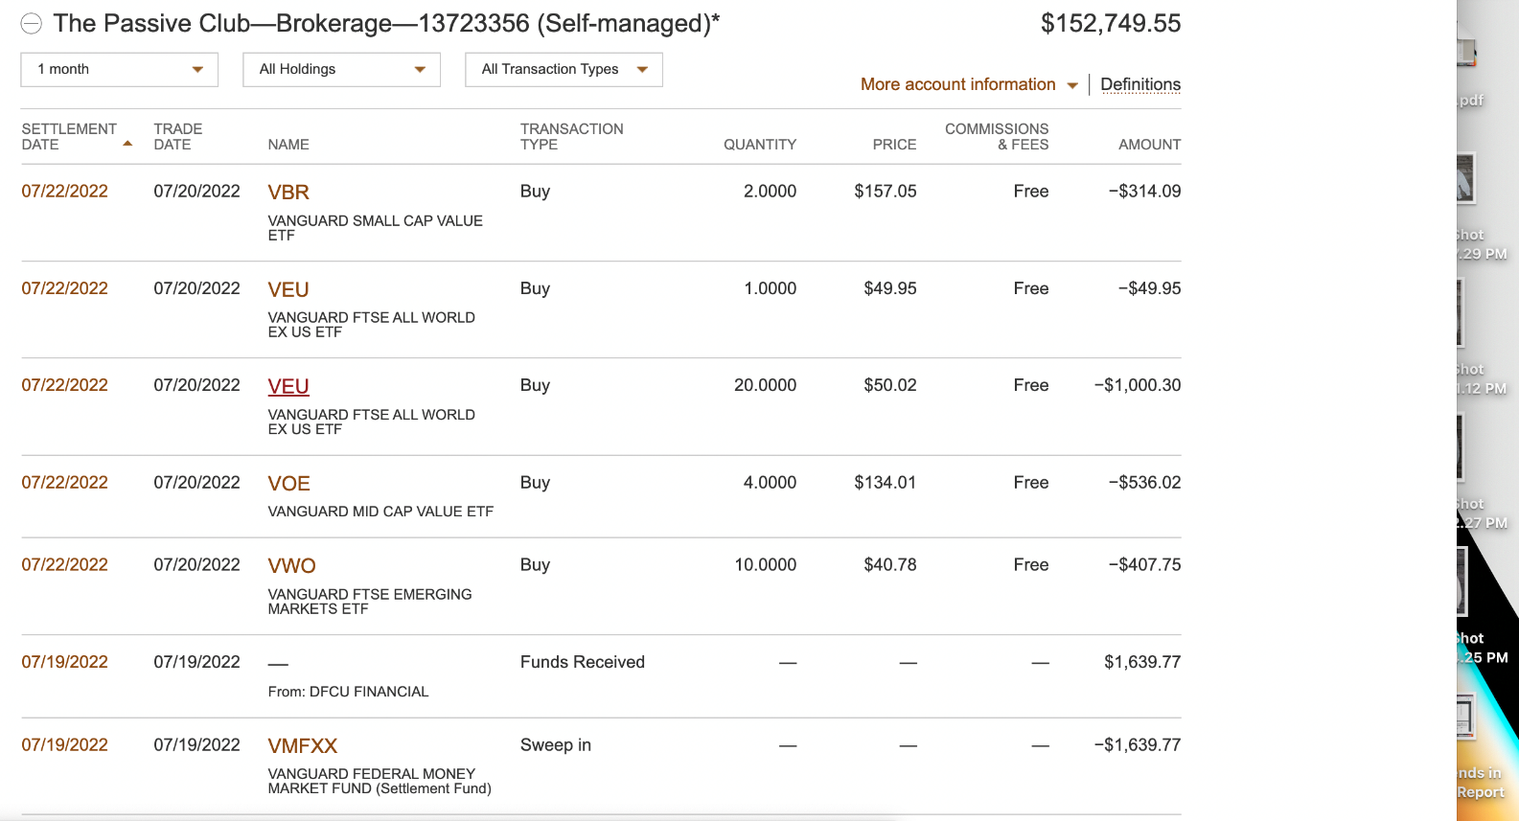

- Old Business
  - Audit update presented by Jody:
    - Vote on Scott and Jody’s recommendation:
      - Members should add phone numbers to contact information in the Bivio rooster
        - As of 7/15/22 – We still need 17 people’s phone numbers
      - Receipts should be uploaded to Bivio as PDF in receipt folder.
      - Pdf statements (DFCU & Vanguard) should be uploaded to Bivio.
      - Minutes and Treasures Report to contain more details on expenses and withdrawals.
      - Recommend we target deposits after 1st of the month and before meeting (especially at end of year – Dec).
      - Recommend Before leaving the club and receiving final check – to confirm deposits and withdrawal amounts! Recommend a Quarterly and or Simi Annual Audits.
  - Helen needs assistance in the following items:
    - Printed taxes – She still does not have it and needs to send it out by the end of July. – Georgeline will email both Phil and Helen to work out the printing of this document.
      - Manu will follow up to ensure that it is done.
  - Do we want to do a lunch or dinner for the Club members? – John will send out email.
  - Georgeline will propose how to make the old business section more readable. She will get Jody’s input and then send email for the clubs to provide their feedback.
    - On 7/15/22 Jody and Georgeline met and came up with the following changes:
      - Delete sections that has been resolved because it has been saved in previous meeting minutes.
      - Carry only things that are outstanding
  - Jody recommending that as part of the Treasurer’s report, we get at glance to how we are performing against the market. – This is done and included at the bottom of the Treasurer’s Report.

- New Business
  - Helen is unable to submit the filling taxes responsibility. Manu will coordinate the filling of taxes by Phil.
  - Helen proposed adding things communicated via email after meeting inside the meeting notes.
  - Jody and Manu will meet with Helen to simplify the Treasurer Report.

Submitted Georgeline Mitchell

