The Passive Club (TPC)
Meeting Minutes for September 21, 2022
Meeting called to order at 11:03 AM | Meeting adjourned at 11:31 AM

Officers | Name | Officers | Name
President | Manu Pasari | Vice-President
Treasurer | Helen Sorser | Treasurer (bkp)
Secretary | Georgeline Mitchell | Secretary (bkp)

Member Name | Present | Member Name | Present | Member Name | Present
Alan Hull | ☐ | Helen Sorser | ☒ | Sriram Padi | ☐
Carolyn Collins | ☐ | Manu Pasari | ☒ | Javarri Little | ☐
Catherine Chall | ☐ | Morresa Meyer | ☐ | Youmin Zheng | ☐
Damian Stone | ☒ | Percy Antonio | ☐ | Jeff Scott | ☐
Jody Tarquinto | ☒ | Phil York | ☒ |  | ☐
John Janci | ☐ | Scot Ferman | ☐ |  | ☐
Georgeline Mitchell | ☐ | Srinivas Ponugoti | ☒ |  | ☐
Gerry Wholihan | ☒ |  |  |  | ☐

- Georgeline reviewed meeting minutes from 8/17/2022:
Al motioned to accept
Phill second, no one opposed
Motion passed.

- Current Months Treasurer’s Report was reviewed by Helen:
Available Cash for investment $1,428.98
Jody motioned to accept
Phill second, no one opposed
Motion passed.

- Portfolio Action – Buys/Sells:

Documents location:
https://docs.google.com/spreadsheets/d/1j4jKxPI5rqnW1hsBRrX63jzIZZ0Dl80ak9CXDc2lJDU/edit?usp=sharing

September Buys:
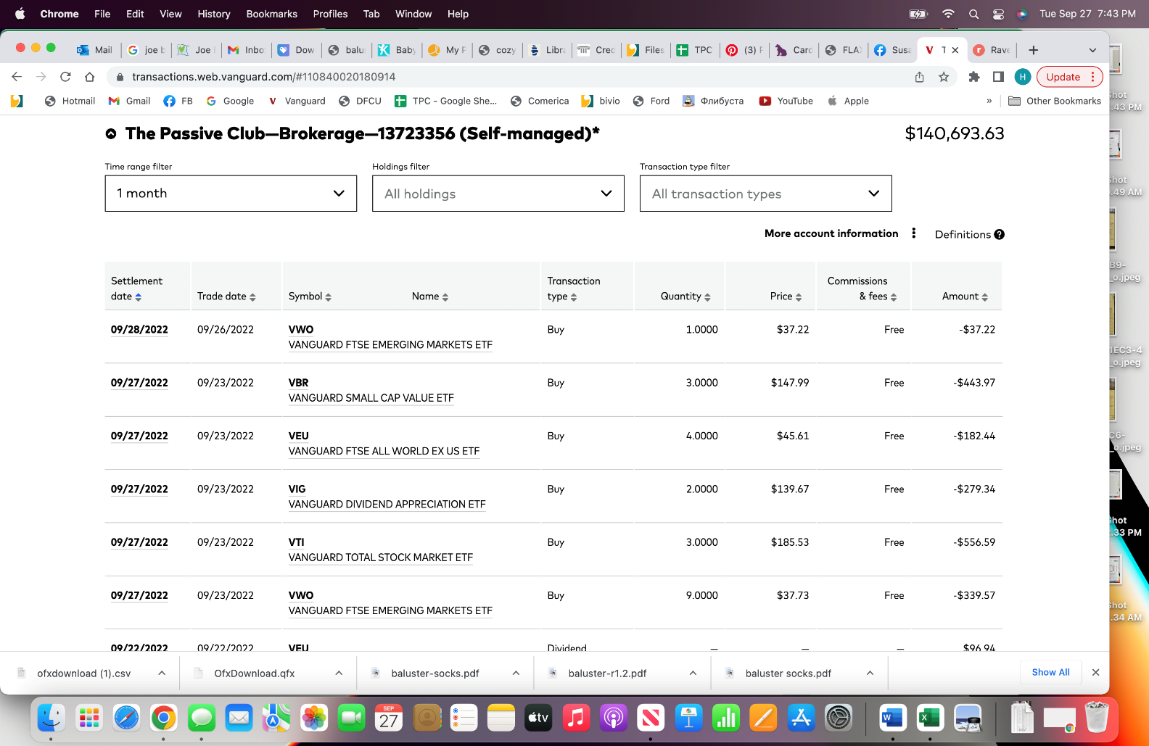

- Old Business
  - Audit update presented by Jody:
    - Vote on Scott and Jody’s recommendation:
      - Members should add phone numbers to contact information in the Bivio rooster
        - As of 7/15/22 – We still need 17 people’s phone numbers
      - Receipts should be uploaded to Bivio as PDF in receipt folder.
      - Pdf statements (DFCU & Vanguard) should be uploaded to Bivio.
      - Minutes and Treasures Report to contain more details on expenses and withdrawals.
      - Recommend we target deposits after 1st of the month and before meeting (especially at end of year – Dec).
      - Recommend Before leaving the club and receiving final check – to confirm deposits and withdrawal amounts! Recommend a Quarterly and or Simi Annual Audits.
  - 2021 Taxes:
    - 2021 taxes are filed
  - Jody and Manu will meet with Helen to simplify the Treasurer Report.
  - New officer list will be shared by Manu through the TPC email
  - If available in the month of October to meet for lunch or dinner, send an email to John so that he can arrange the date.

- New Business
  - Discuss revisiting of how Bivio site is set up per Helen – “The Bivio site where we store our club documents like meeting minutes, financial statements and information, guidelines and supporting documents needs to be revisited. It is hard to navigate, and we have documents in multiple places, like partnership agreements, club audit documents, etc. We need to create a road map of the site, evaluate available documents, purge what is not needed and align what's needed. For example, the partnership agreement needs to be signed every year.”
    - Site cleaning
    - Creating a partnership agreement
  - Vanguard access – discussion with John
  - Vanguard allows to buy partial shares (per Jody) and it is a subject for discussion
    - Validate if Bivio allows partial shares
    - Complexity of execution (for the treasurer)
  - Vanguard $7 discrepancy – Helen to prepare analysis. Meet with Jody and Manu
  - Jody will talk about portfolio makeup during October meeting

Submitted Helen Sorser

