The Passive Club (TPC)
Meeting Minutes for June 21st, 2023
Meeting called to order at 11:04 AM | Meeting adjourned at 11:20 AM

Officers | Name | Officers | Name
President | Manu Pasari | Vice-President | vacant
Treasurer | John Janci (acting0 | Treasurer (bkp)
Secretary | Sriram Padi | Secretary (bkp)

Member Name | Present | Member Name | Present | Member Name | Present
Alan Hull | ☒ | Helen Sorser | ☐ | Sriram Padi | ☐
Carolyn Collins | ☐ | Manu Pasari | ☒ | Javarri Little | ☐
Catherine Chall | ☐ | Morresa Meyer | ☐ | Youmin Zheng | ☐
Damian Stone | ☐ | Percy Antonio | ☐ | Jeff Scott | ☐
Jody Tarquinto | ☒ | Phil York | ☐ |  | ☐
John Janci | ☒ | Scot Ferman | ☐ |  | ☐
Georgeline Mitchell | ☐ | Srinivas Ponugoti | ☐ |  | ☐
Gerry Wholihan | ☒ |  |  |  | ☐

  - Member to member transfer process will be used to payout Percy
  - $787.84 available for investments, will be holding to payout Manu
  - 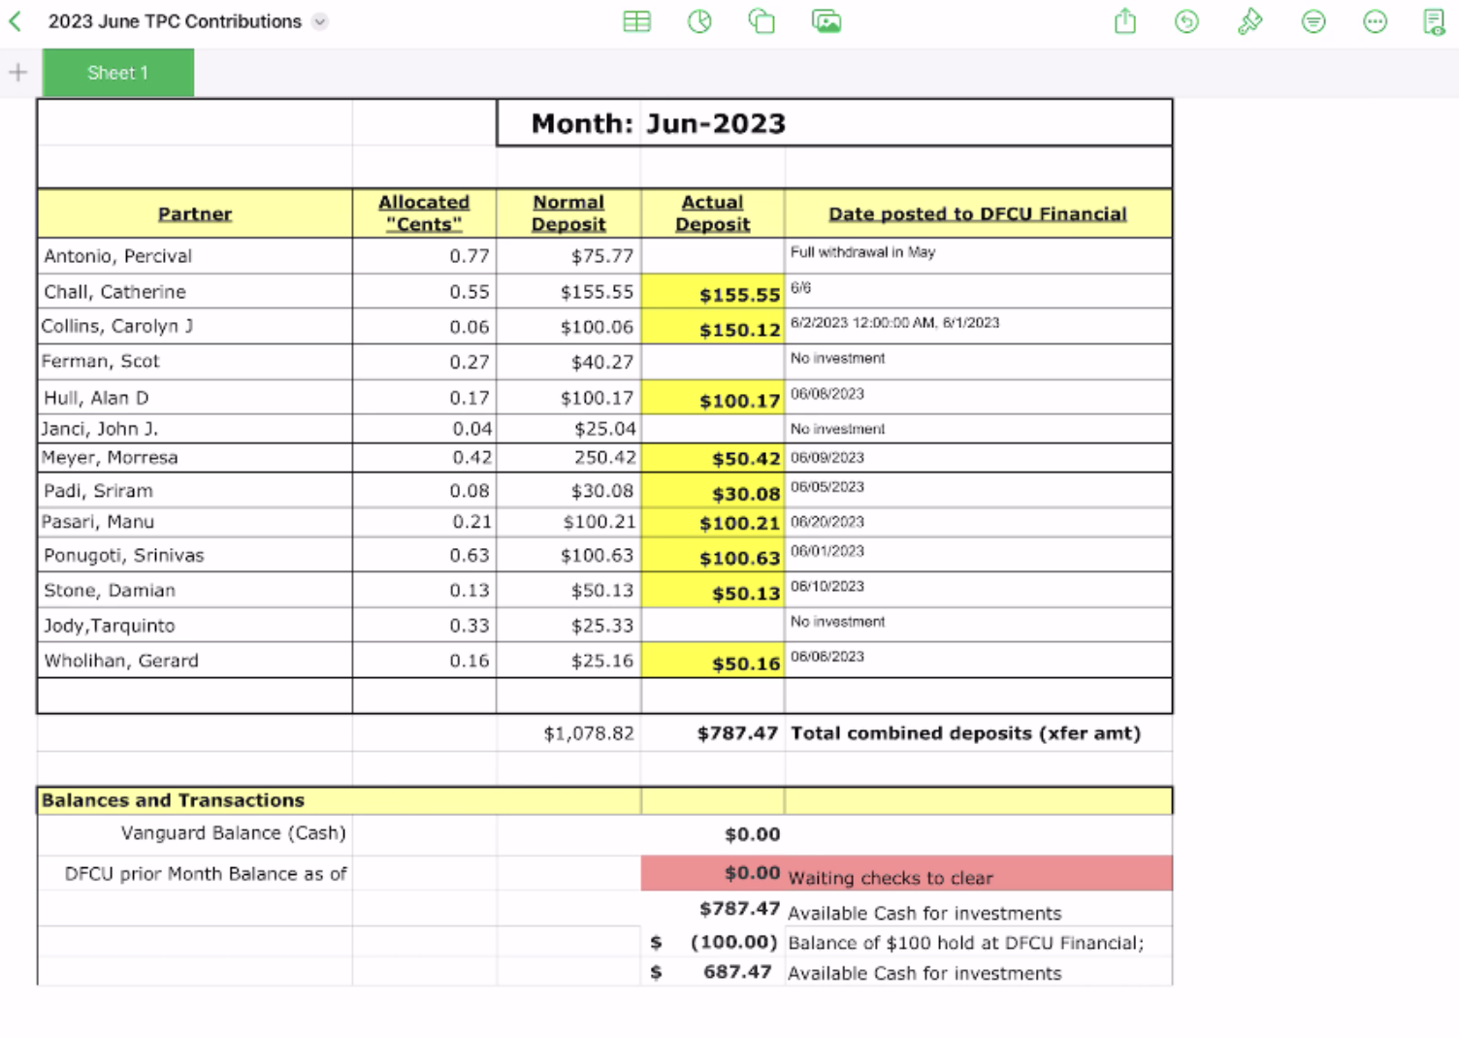
  - Manu requested a partial withdrawal of $4000
  - Manu to consolidate the minutes for the earlier.
    - High-level minutes from May reviewed, Jerry Shared his notes.
  - Send a note out to the group that the meeting timeslot will be changed to Friday, next will be July 21st
  - Proposals for officers for the next session:
    - Presidents - Jerry
    - Vice President - Jody
    - Treasurer - Manu
    - Secretary - John
  - Proposal to move to tools (www.Iclubcentral.com) that would automate the integration of accounting systems with brokerage account
    - Jody to helping with an introductory session.

- Old Business
None discussed

- New Business

Submitted
Manu on July 20th 2023

