Meeting Minutes - Yankee Chapter Model Club

GoToWebinar, 11:00AM ET / 8:00AM PT

December 10, 2022
In attendance (310 registered, 41 visitors)
Members: Jack Finn, Stephen Roy, Brent Goll, Ira Haas, Liz Tobin and Sriram Madabhushi were all present.
Esteemed visitor: Joe Farrell.
Visitors: See list at the end of the minutes.

Opening: Brent called the meeting to order at 11:01 AM ET and introduced the club and members to visitors and explained the general information about the club.

Educational Segment: No education segment for this month.

Minutes from last meeting – Sriram presented minutes from last month’s meeting and they were accepted as presented. Uploaded the Final November 2022 minutes in the Public folder on Bivio.

Treasurer’s Report – Jack presented the treasurer’s report for November 2022, and they were accepted as presented. Jack also presented the S&P (SPY) comparison for the portfolio.

Bivio positions:
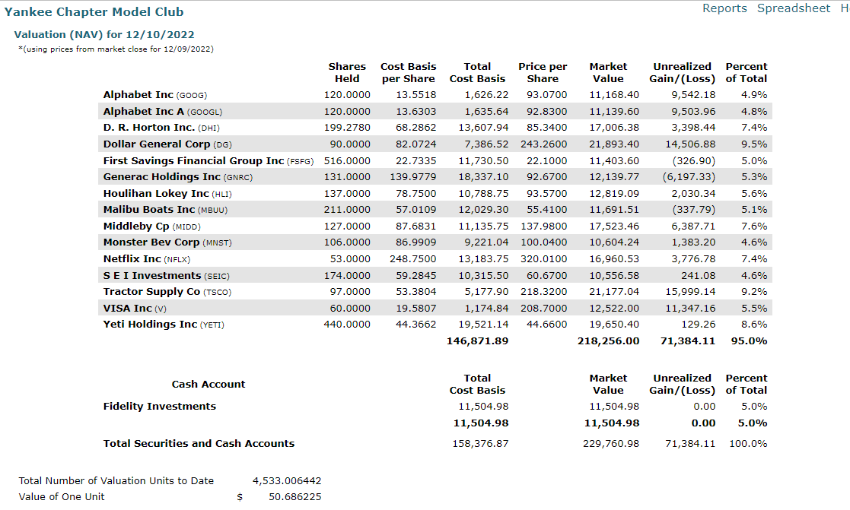

SSG size diversification report as of market close 12/10/2022:
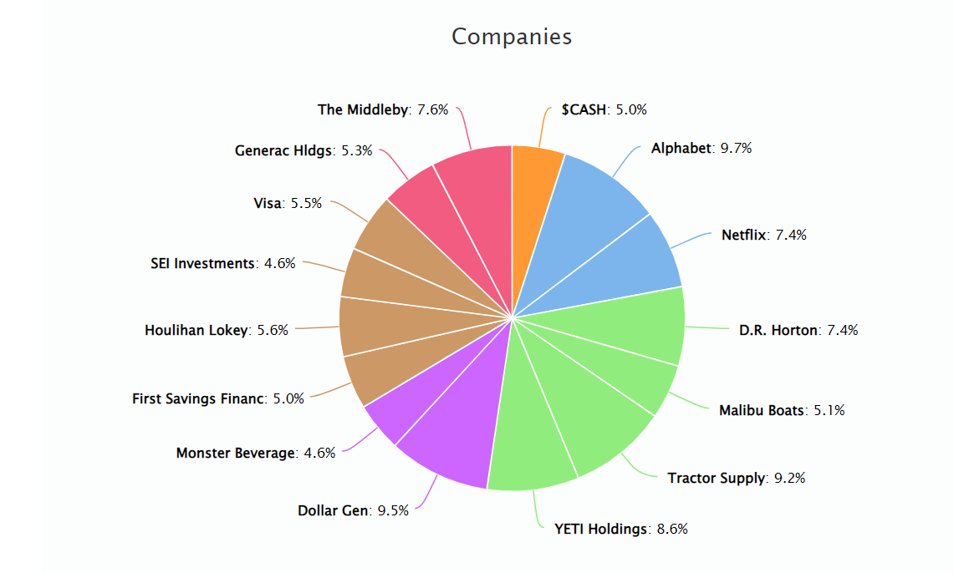

Stock Study Presentation – Stephen presented the SSG analysis for Align Technologies (ALGN) and he recommended purchase of this stock. Club members discussed and presented their input on the discussion.

Review of Stock Portfolio: Members presented their updates for stocks they were watching. Jack presented the Bivio Valuation Report during the individual presentations. Sriram also presented the Manifest Investing Summary and the BetterInvesting PERT. After individual presentations, club members discussed status of all the holdings.

Watchlist update: No specific recommendations from the updated watch list discussions, IBP (2/12/2022), ASML (7/9/2022) and MPWR (9/10/2022). INMD (11/12/2022).

Buy/Sell decisions –
SELL: None.
BUY: Purchase ALGN with half of the available cash and put the remaining for a limit order to purchase INMD at $32.00. Revisit in January. ALGN watcher will give monthly updates and keeps a track.

General club business:

Old:
  - Portfolio challenge: YMIC doing better this month, with being placed first among a list of a total of 23 clubs and individuals.
  - Club address relocation to Texas: Sriram provided input that an IRS form with address update is only official requirement. Also the county Name Certificate to be filed.

New:
- Discussed the Bivio monthly fees and it was noted that we grandfathered into no fees.
- Elected new officers for the 2023:
  - Stephen – President
  - Liz – Vice President
  - Jack - Secretary
  - Ira – Treasurer
  - Sriram – Assistant Treasurer
  - Brent – Past President

Questions from visitors – Mostly answered by Joe in the back room.
- Some of the up/ds ratios on your chart are very high they don't seem realistic
  - Nothing on the website discussed tatoos and I saw nothing on the topic in what I studied before I bought it last month. – Joe
- Can chiropractors use this? Or just a doctor?
  - I do not see the answer to this in the website information. No professions except MDs are noted.
- How often do you rescreen the selections you demonstrated today?
  - Most of us do this whenever we plan to make a presentation for the club. In addition, the tool is excellent if you are working to expand your personal portfolio.
- What was the purpose of relocating your address?
  - To take advantage of changing taxe requirements and to maximize the profits.

YouTube Channel: Yankee Model Investment Club.
Link: https://www.youtube.com/channel/UC8qHPmYMPky4sWKMldWgckA

Closing: Meeting was adjourned at 12:50 PM EDT.

Next Model Club Meeting on Saturday, 12/10/2022 at 11AM ET online using GoToWebinar. All attendees should already be registered and will receive a reminder email from GoToWebinar (one week, one day and one hour) before the meeting.

Visitors: Harold Ackerman, Russ Bailey, Debra Bradley, Thomas Brooks, Ron Bruyn, Ciprian Cosma, Lavon Deepe, Carmen Dudley, Ken Eaton, Stephen Emmerich, Reddy Ganta, Jessica Glant, John Hangen, Bo Horton, Freida Joyce, Todd Koch, Brian Koenig, Bakul Lalla, Stephen Li, Tom Loftus, Jeff Lucas, Don Lynaugh, Leslie Maddison, Atul Manocha, Linda Martino, Donna Nichols, Victor Olivas-Cruz, Kirpal Parmar, Daniel Perrier, Christian Posada, Nick Prabhu, Vincenzo Race, Suzanne Ryan, Georgia Scotti, Lois Selman, Philip Serowik, Lucile Sorrells, Bill Stafford, Kirsti Stewart, Ruth Thomas and Barbara Walthour.

