Meeting Minutes - Yankee Chapter Model Club

GoToWebinar, 11:00AM ET / 8:00AM PT

January 14, 2023
In attendance (318 registered, 41 visitors)
Members: Jack Finn, Stephen Roy, Brent Goll, Ira Haas, Liz Tobin and Sriram Madabhushi were all present.
Esteemed visitor: Joe Farrell.
Visitors: See list at the end of the minutes.

Opening: Steve called the meeting to order at 11:01 AM ET and introduced the club and members to visitors and explained general information about the club.

Educational Segment: Liz gave a short Powerpoint on “Dividend Stocks” (click for PDF). She recommended an upcoming presentation on February 23rd, called “Investing in Dividend Stocks.” You can register for the presentation here. She also recommended a series of articles on dividends from BI available here.

Minutes from last meeting – Sriram presented minutes from last month’s meeting and they were accepted as presented. Uploaded the Final December 2022 minutes in the Public folder on Bivio.

Treasurer’s Report – Ira presented the treasurer’s report for January 2023, and they were accepted as presented.

Bivio positions:

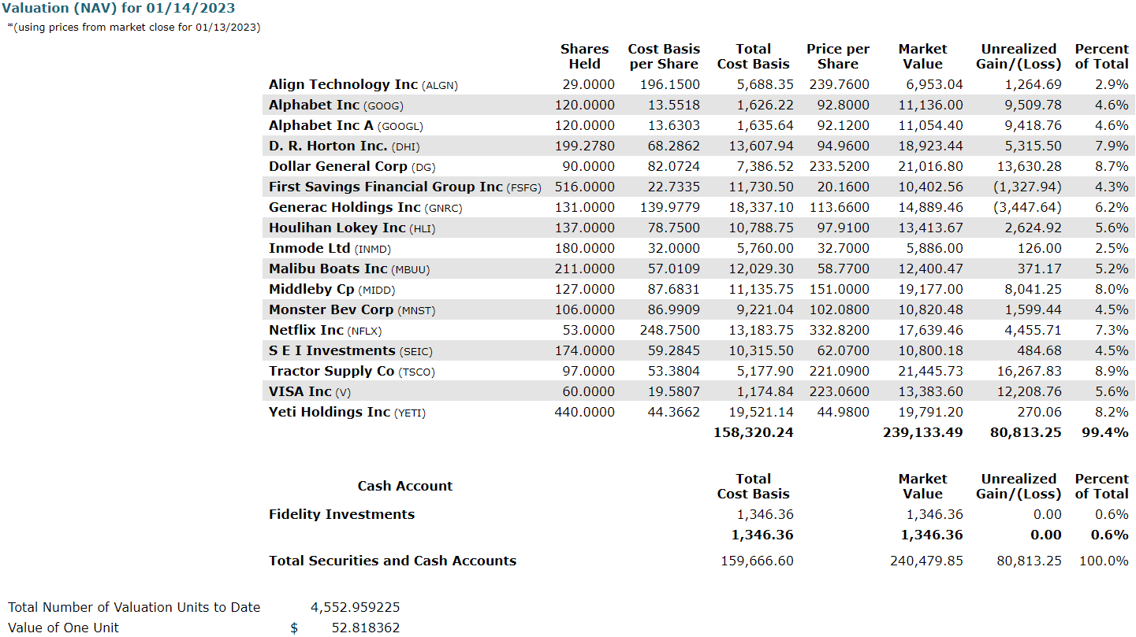

SSG size diversification report as of market close 1/13/2023:
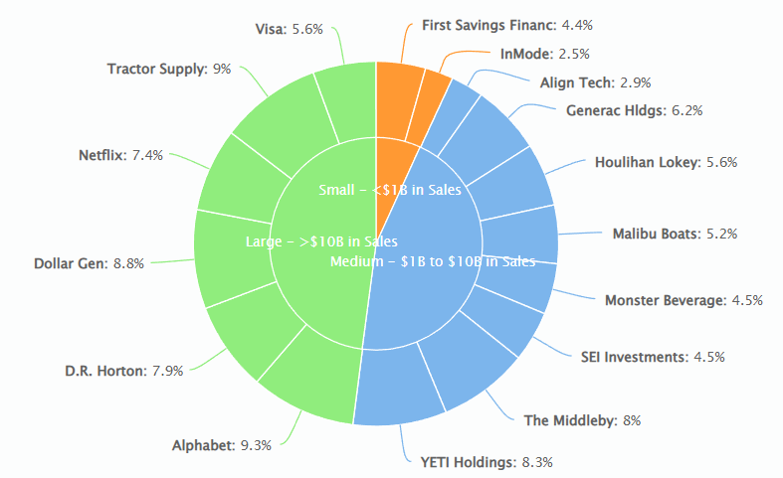

Stock Study Presentation – Jack presented the SSG analysis for Clearfield Inc. (CLFD) and recommended purchase of this stock. Club members discussed and presented their input on the discussion.

Review of Stock Portfolio: Members presented their updates for stocks they were watching. Sriram presented the Bivio Valuation Report during the individual presentations. After individual presentations, club members discussed status of all the holdings.

Ira reported that the ALGN, which was on a short-term watch list did phenomenally well for the one month since we bought it and experienced 21% growth in stock price. He recommended to sell and realize the profit.

Watchlist update: Two BUY recommendations from the updated watch list discussions: IBP (2/12/2022) and MPWR (9/10/2022). ASML (7/9/2022) and INMD (11/12/2022) are both HOLDs.

Buy/Sell decisions – After discussion the club decided the following:
SELL: Sell ALGN.
BUY: Enter a limit order to purchase INMD at $32.00 with proceeds from sale and available cash.
General club business:
Old:
  - OLC Portfolio challenge: YMIC remains ahead by about $10,000. ZYNX is best stock. We have a chance to change portfolio up until Feb 17th. Item for Feb. 11th meeting.
  - Club address relocation to Texas: Jack reported that address change form was sent to IRS last month. Jack will upload form to Bivio.
  - Sriram is still waiting for clean signed forms from a couple of people to file the Bexar county form for Name Search.
  - Jack still needs signatures for Fidelity forms to change trading and check-writing authority.
    - Checkwriting form DONE!
    - Investment Club Cash Account form needs:
      - Steve (Jack - resend form to Steve) (sign. received 2/6)
      - Sriram
      - Liz (will send to Jack by snail mail)
New:
- Brent was assigned ALGN for stock watching.
- GoToWebinar max meeting limit – Joe will manually input the names to start a new set of 50 monthly meeting invitations, as we are reaching the limit.

Questions from visitors – Mostly answered by Joe in the back room.
- What determines if a stock is in the sell zone?
  - We analyze what we think the sales and earnings growth will look like out to 5 years in the future. Based on those estimates we then analyze what we think the price/earnings (P/E) ratio will do in that time period. Given those estimates we determine what we think the stock's price range will be over that time. Given the current price we analyze the upside vs downside ratio will be and when a stock's price moves to the upper or lower end of the range, we believe the sale may be appropriate; either because we've gotten all the price profit we will see or because our analysis was wrong and we need to get out and buy something better with the sales proceeds. – Joe
- How did you come across this stock?
  - Our partners use a variety of sources, SSG, Manifest, Value Line, Morningstar, most brokerages, etc provide search engines that search based of your request parameters. Everyone does it a little differently. - Joe
  - I think found it looking for small companies in the industrial sector using the online search tools on the BI website. - Jack

YouTube Channel: Yankee Model Investment Club.
Link: https://www.youtube.com/channel/UC8qHPmYMPky4sWKMldWgckA

Closing: Meeting was adjourned at 12:50 PM EDT.

Next Model Club Meeting on Saturday, 2/11/2022 at 11AM ET online using GoToWebinar. All attendees should already be registered and will receive a reminder email from GoToWebinar (one week, one day and one hour) before the meeting.

Visitors: Russ Bailey, Jeffrey Blomberg, Janet Blaser, Thomas Brooks, Ron Bruyn, Veronica Capers, Ciprian Cosma, Dana DAgostino, Albert DeCubelis, Lavon Deepe, Ken Eaton, Stephen Emmerich, Carol Fairchild, Bruce Fuelling, James Gallagher, Reddy Ganta, Jessica Glant, John Hangen, Richard Hill, Bo Horton, Freida Joyce, Patrick Klune, Brian Koenig, Bakul Lalla, Don Lynaugh, Atul Manocha, Ana McBayne, A Pope, Christian Posada, Nick Prabhu, Lois Selman, Philip Serowik, Lucile Sorrells, Ruth Thomas, Cassandra Vickers, Cynthia Williams, Ray Woods, Terry Wyatt and Dennis Young.

